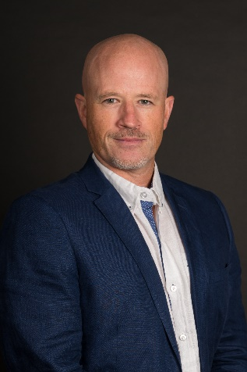
Scott Jelliman, Account Manager, Arconas. Since 2015, Scott has been an integral part of the Arconas Aviation Solutions Team, managing airport clients along the Eastern Seaboard-US and Canada. In his current role, Scott consults with clients to provide the best furniture solutions to meet each airport’s project goals and requirements, while maintaining strong relationships. In addition to creating new business opportunities, Scott also helps promote Arconas’ brand and position within the aviation industry. Scott holds a Bachelor’s Degree in Marketing from the University of North Carolina-Charlotte.

